Linear Actuator
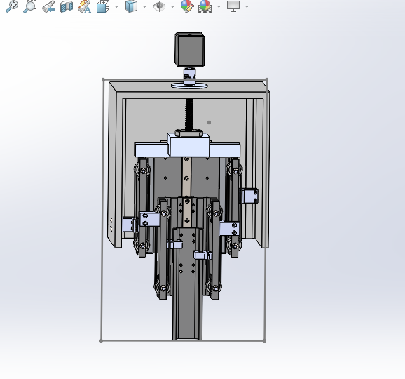
(Electromechanical)
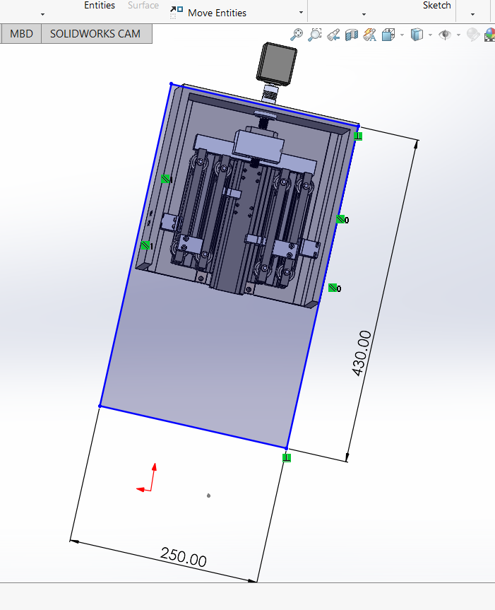
DYNAMIC LOAD

Lead screw load calculations:-

L=(C/F)³x100000m
L=Travel life (m)
C=Bearing Dynamic load of capacity(N)
F=Applied load(N)
(C/F)³=L/100000 m
C/F=$\sqrt[3]{L/100000}$ m
Selection of Lead Screw
Required Dynamic load capacity:
C=F x $\sqrt[3]{L/100000}$ m
[: Max Condition
F=250 x 0.101 =25kg]
C=250 x${ (\frac{28000000}{100000})}^{1/3}$m
C=1635N-m
C=1.635KN-m [Accordingly the lead screw has been selected which has a basic dynamic load range:0.68kN-8.93kN]
MG-series:

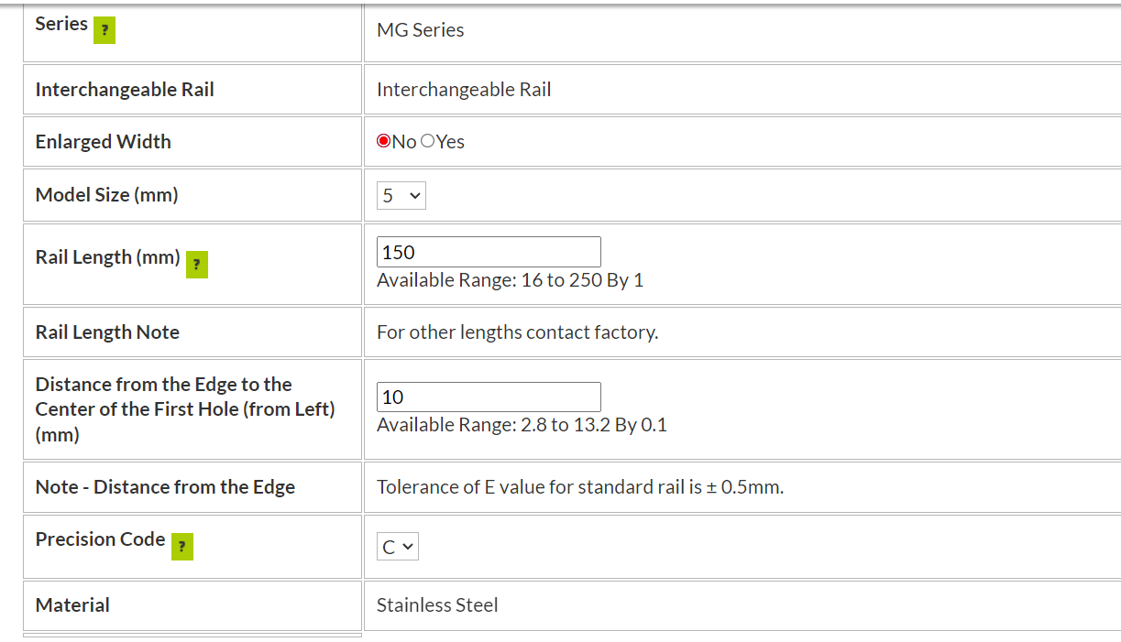
Ball Screw
Static safety factor:
The lower limit of (fs)
- to 3.5
- to 5.0
Ball screw selection:
Mass of system=15kg
Required life=20000km
F=250 x 0.101
F=2.5kg
(F=140 x 0.101 F=14.1kg)
C=100 x (${280)}^{1/3}$
C=654.21N
C=0.65KN
Weight=6466.52 grams
=>6.46 kg
=>3.4kg
Velocity [: The speed is v=d/t;
v=>200/65 33.33=450/t;t=450/33.33=>t=12.9s]
v=>33.33mm/s
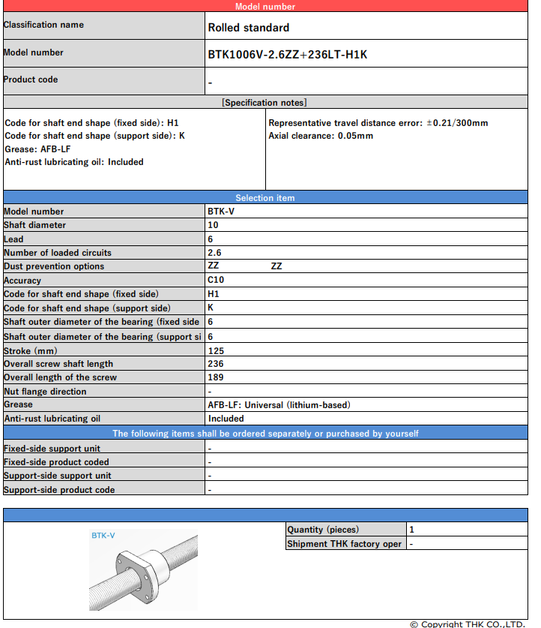 [: Stroke length=125mm]
Stepper Motor Calculation
Torque calculation
Motor torque [T(N.M)]
[: F=m x g
F=15kg x 9.806
T=F*L/2*Pi*E [: where E is efficiency of motor]
T=137.34 x 5/6.28 x 0.9
T=121.5 N-m
F=147.09N]
T=F x r
T=147.09x 250mm
T=36772.5 N-mm
T=36.772N-m
[: 1Nm=10.1967 kg-cm]

Calculation of Power
[P=(F x S)/t
P=147.90 x 430/t
P=63248.7/t [:t=12.9mm/s]
P=4930 N-mm/s [:1 nm/s=1 watt]
P=4.93 N-m/s =>4.93 watt] [Amp=0.2]

Calculations of Timing Pulley
M=d/z
M=18.25/12
M=1.52

P=πm
P=π x 1.52
P=5mm

Lead=Number of starts x pitch
Lead=2 x 5=>10
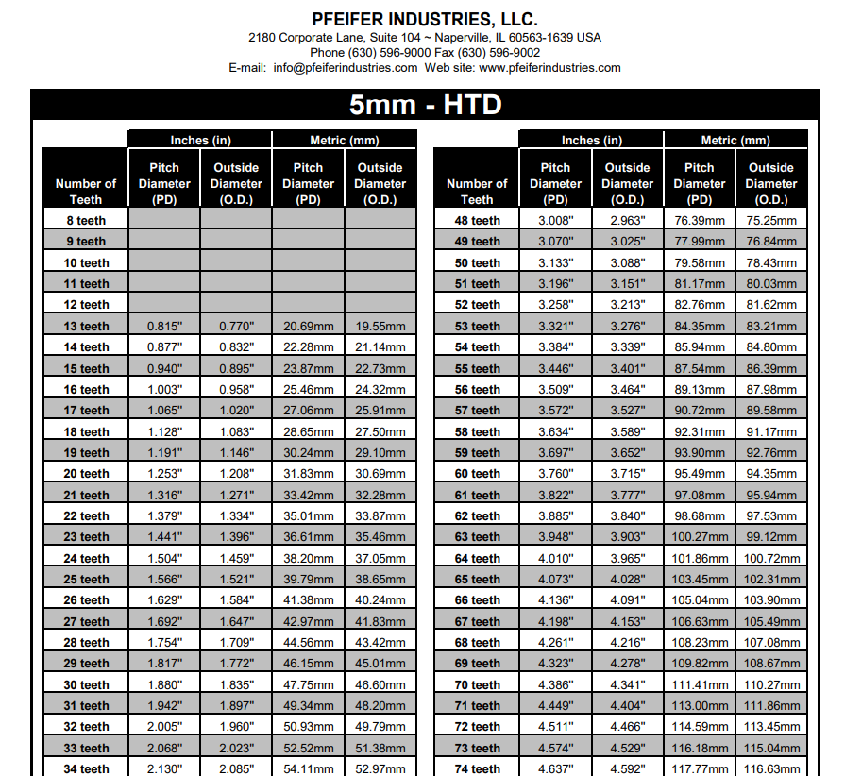

Tooth thickness ½ of pitch
S=πm/2
S=π x 1.52/2
S=2.38

Selection of Timing Pulley


